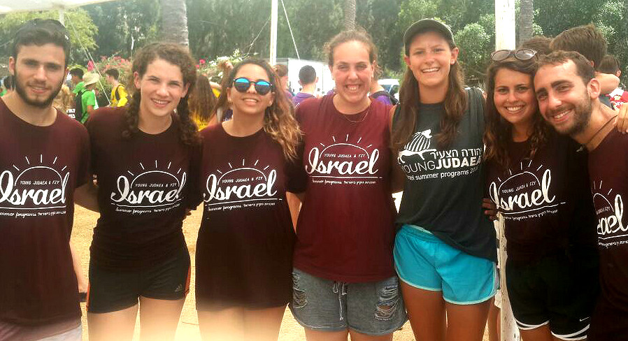
Are you a Judaean and itching to get back to Israel this summer, as a YJ staffer? We are looking for super staff members for Machon, YJ’s 4 week teen summer program in Israel! If you are upbeat, energetic, care about Israel and YJ, and understand informal education, then we want to hear from you!
Requirements:
- Over 21

- Grew up in the YJ movement

- Worked in summer camps (preferably TY)

- Participated on Machon and/or Year Course (even better if you did both)

- Love Hadracha and not afraid to work hard and get your hands dirty

- The program dates are June 27th- August 4th, 2017. Staff members will be required to be available and work from home for few more dates during May and June .(Dates TBD)

Send your CV to jobs@yji.org.il to apply!

