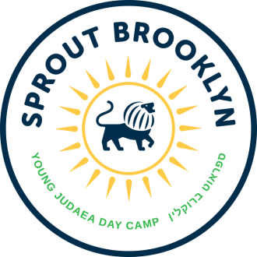
Young Judaea Sprout Brooklyn Day Camp – Unit Head
Young Judaea Sprout Brooklyn Day Camp, located in Red Hook, is a Hebrew dual-language camp for children entering Pre-K through 4th grade. No previous Hebrew experience is necessary to be part of the Sprout Brooklyn community.
Sprout Brooklyn is a place where children from a wide spectrum of Jewish backgrounds join together to create a joyful, diverse community built on Jewish values, a connection to Israel and the Hebrew language. Sprout Brooklyn provides campers with a deeper connection to Israel, to the Jewish community and to themselves.
We offer a unique experience where Hebrew, Jewish values and a love of Israel enhance everything we do. Some of our activities include swimming, sports, cooking, performing arts, visual arts, creative play and the exploration of nature, all interwoven with dynamic experiential Jewish programming and Hebrew.
We are looking for a mature, responsible, energetic and nurturing person for our Unit Head position. This is an extraordinary opportunity to work collaboratively with a passionate team to build a new Jewish Day Camp. Camp runs from the July 3 – August 18. Staff training is June 24 – July 1. The camp day runs from 8:00am - 5:30pm, Monday – Friday.
Responsibilities

Staff
- Build strong relationships with staff
- Supervise counselors - Manage staff performance and well-being
- Perform ongoing staff training, as necessary
- Oversee writing of camper reports
- Be aware of dynamics among co-counselors and mediate issues as they arise
- Report directly to Assistant Director regarding staff issues and support
- Coordinate and oversee substitute coverage for absent staff members

Campers
- Know each camper by name and group
- Know of all camper allergies and medical conditions
- Support the well-being and quality of experience of all campers
- Know each group’s daily schedule and provide additional staffing support, when needed
- Address camper behavioral and social/emotional issues with counselors
- Report directly to Assistant Director regarding camper behavioral and social/emotional issues
- Call parents regarding any issues with campers
- Oversee camper arrival and dismissal

Program
- Part of the team that oversees quality of each program area
- Be knowledgeable about the camp schedule and calendar

Camp Leadership
- Serve as part of the camp Leadership Team, which consists of the Director, Assistant Director, Operations Director, and Co-Director of Camper Care
- Help plan and implement Staff Orientation
- Part of crisis management team in case of emergency

Requirements:
- BA required, MSW or other Master’s Degree preferred
- Experience attending or working at a summer camp
- Supervisory experience
- Experience working with children ages 3 – 9
- Passion for Jewish and Israel Education

Please contact Elyssa Gaffin at elyssa.gaffin@youngjudaea.org or 917-595-1500 ext. 221

