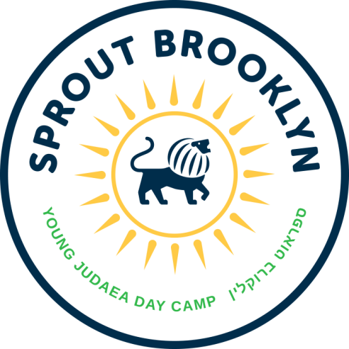

Sprout Brooklyn Day Camp Counselors, Specialists and CITs Needed

Young Judaea Sprout Brooklyn Day Camp, located in Red Hook, is a Hebrew dual-language camp for children entering Pre-K through 4th grade. No previous Hebrew experience is necessary to be part of the Sprout Brooklyn community.

Sprout Brooklyn is a place where children from a wide spectrum of Jewish backgrounds join together to create a joyful, diverse, Jewish community built on Jewish values, a connection to Israel and the Hebrew language. Sprout Brooklyn provides campers with a deeper connection to Israel, to the Jewish community and to themselves.

We are looking for creative, energetic, nurturing people to fill a variety of Counselor, Specialist and CIT positions at camp this summer. This is an extraordinary opportunity to work collaboratively with a passionate team to build a new Jewish Day Camp. You will help create a joyful Jewish community and truly make a difference in the lives of children. Specialists needed include: yoga, music, sports, nature, STEM, cooking and martial arts. Camp runs from the July 3 – August 18, Monday – Friday from 8:30am – 3:30pm with a week of staff training from June 23 – June 30.

Requirements
• Counselors and Specialists must be at least 18 years old
• CITs must be entering Junior or Senior year of High School
• Passion for Jewish and Israel education
• Experience attending or working at a summer camp
• Experience working with children ages 3 – 9
• Enthusiasm and the willingness to be silly
• Hebrew fluency is a plus

Please contact Elyssa Gaffin at elyssa.gaffin@youngjudaea.org or 917-595-1500 ext. 221.

